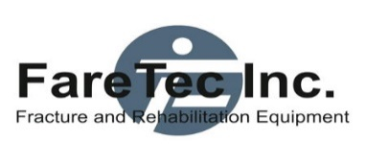

1610 W Jackson Street • Painesville, Ohio 44077 • 440-350-9510 • [www.faretec.com](http://www.faretec.com)

**INSTRUCTIONS FOR USE**

**REDI SPLINT**

INTENDED USE:

Redi Splint is a flexible splint which is aimed to provide pre-hospital immobilization to the fractured limb or sprain. Redi Splint is intended for single use.

INDICATIONS: Limb fractures and sprains.

INTENDED PATIENT GROUP: Adults and children with limb fractures, sprains, or any situation where patient’s limb needs to be immobilized.

INTENDED USER: Healthcare professionals.

INSTRUCTIONS:

Depending on area protocol, the splint will be applied by a healthcare professional according to the injury sustained by the patient. This product is designed to aid in pre-hospital immobilization on a very large number of limb injuries. Its exact method of application is dependent on the type of injury and the person applying the splint. Typically, it is formed to contour the injured limb to support and protect the patient. It is then wrapped with a commercial bandage or first-aid tape, depending on the preference of the first responder. This is an easy means to secure the splint effectively. Splint removal should be done carefully with scissors, by cutting the tape away and then gently pulling the splint off the patient.

CLINICAL BENEFITS: Provide strong support to any fractured limb.

CONTRAINDICATIONS: None.

WARNINGS, PRECAUTIONS & LIMITATIONS: None.

Redi Splint should not be re-used. The re-use of the device can cause limb injury and wound infection.

SAFE DISPOSAL: The product should be disposed in the dedicated area as recommended by the local authorities.

NOTICE: Please report to FareTec or to the competent authority of the Member State in which you use this product any serious incident that has occurred and you suspect is in relation to this device. If you suspect a potential defect or a product has not met your expectations, please report this to the Company and provide as much information as possible. Company phone number: +1-440-350-9510



FareTec Inc, 1610 West Jackson St, Painesville, OH 44077 USA, (p) 440-350-9510

(f) 440-350-9520, www.faretec.com

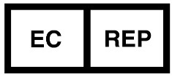 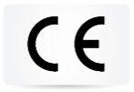

CMC Medical Devices & Drugs S.L., C/ Horacio Lengo n18, C.P 29006 Málaga-Spain

|  |  |  |  |
| --- | --- | --- | --- |
|  | Manufacturer |  | Authorized representative in the  European  Community |
|  | Medical Device |  | Importer |
|  | Consult instructions for use |  | Catalogue number |
|  | Date of manufacture |  | Batch code |
| do not re-use | Do not re-use |