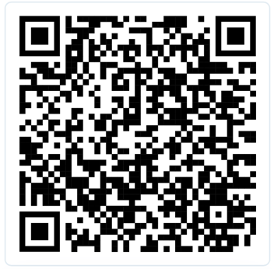

Scan here for Instructional Video


InciTent ™ - Patient Protection Pod – Quick User Manual
Purpose: InciTent ™ provides visual privacy and weather protection for injured or ill individuals or emergency settings.
It can also be used to provide dignity to deceased persons in a short space of time following death.
​

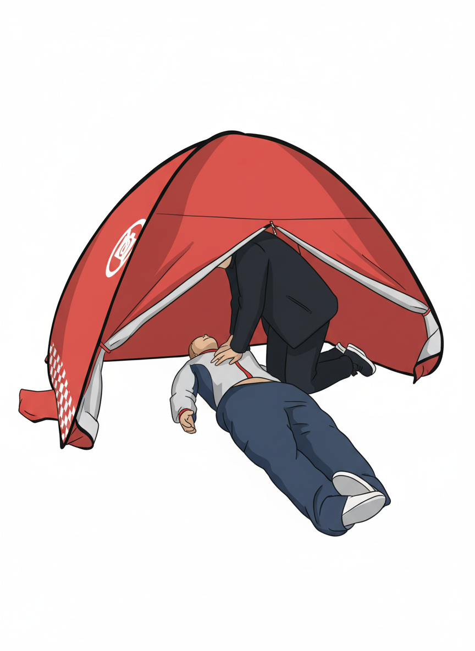
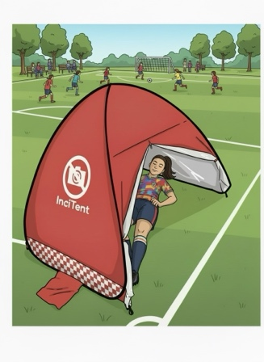
Quick Setup
- Unpack
- Remove pod from storage/carry case
- Place near patient in a clear space
- Unfold pod; it will pop open once released
- Position to shield patient from view, or provide weather protection, ensuring safe access for caregivers
- Where full body coverage is required for tall patients consider placing the tent diagonally over them

Secure
There are 5 methods to secure the InciTent ™.
- No weights needed (indoors for example a shopping centre of outdoors on calm day.
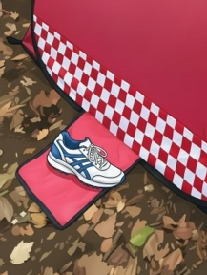
- Use bystanders to stand on foot flaps provided on side of tent. Weights could be used also.

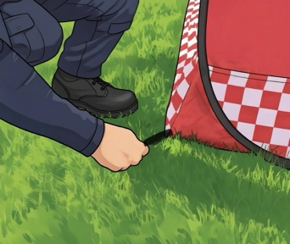
- Use tent pegs on grass or similar surfaces. Be sure to point pegs towards centre of tent.

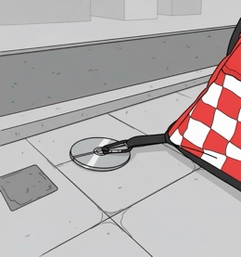
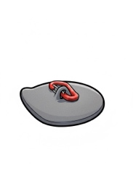
- Use InciPlates to adhere tent to tarmac, concrete or similar surfaces. Place tent in position first, and then stretch each corner before adhering to ground. Point raised edge towards centre of tent.
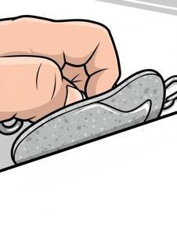

Ensure when peeling InciPlate from release paper that adhesive is attached well to the plate. Dry surface if possible for best for adherence.

- Fill Battenburg stripe at the base of tent with sand or snow to weigh it down.

Confirm ventilation and accessibility at all times during use.
If very breezy, closing the 4th side when not treating patient will reduce wind lift.
NEVER LEAVE THE PATIENT UNMONITORED INSIDE TENT.

Removal & Aftercare
If Single Use
- Collapse
- Fold carefully — follow folding method. (see user video also)
- Remove glue residue from ground if InciPlates used
- If single-use policy, proceed to safe disposal per infection protocols if necessary.

If Not Single Use
- Disinfect reusable surfaces with approved agents
- Dry in a warm drying room
- Inspect for damage
- When dry and clean return to use

​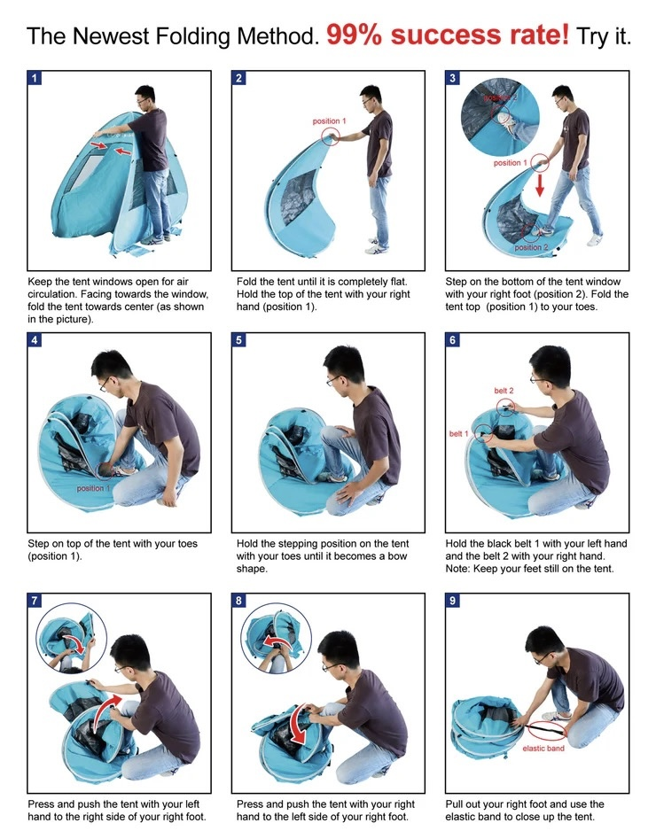

Safety & Legal Notices
Do not block medical access or observation.
Maintain compliance with privacy laws and organization policy.
No photography or recording inside pod without written patient consent.
Deploy ONLY for privacy or weather protection—not as medical restraint or barrier.
Staff are responsible for proper deployment and safe, legal use.
Do not use in high winds.
Do not block access wo a scene with tent.

*For full infection control and legal guidelines, refer to organisational protocols.

